**Using Ansible**

**Ganesh Palnitkar**

To start working with Ansible server and nodes, we have to make sure to comply pre-requisites, like establish ssh key sharing from Ansible server to nodes. To have Python running on the nodes.

**vagrant@ansibleserver:~/project$ ssh-keygen**

**vagrant@ansibleserver:~/project$ssh-copy-id –i ~/.ssh/id_rsa.pub** [**vagrant@192.16.33.11**](mailto:vagrant@192.16.33.11)

**{ source of ssh key} {Location of ssh key} {target user on remote node to copy public key**

**Ansible Components:**

**Inventory file** is the one in which we write all target (remote) servers that we want to manage using Ansible. This file can be updated manually or using a plugin, can be updated dynamically.

A sample inventory file looks like the one shown below.

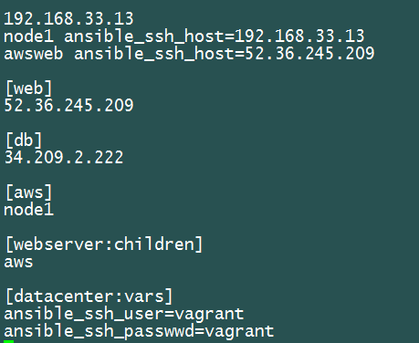

Group variables

Parent group

Group name

Inventory file represented in YAML format

YAML format:

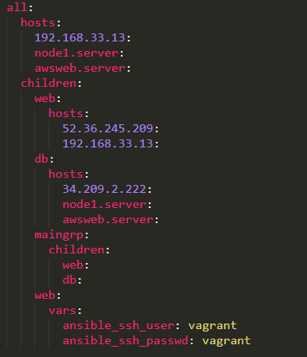

Inventory Management is important for effective and efficient use of Ansible to control your entire environment.

We can break it up in to the environments, like production and test etc. Thus, maintaining separate inventory files for specific environments.

Using **Variables** in **Ansible** inventory management will help in managing the inventory effectively.

This can be done by creating a folder structure as mentioned below.

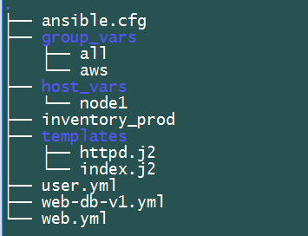

Variables application to all nodes

Variables applicable to specific host only

Variables applicable to host inside a specific group only

**Here variables** mentioned in the ‘all’ file has the least precedence. Vars mentioned in the ‘db’ file which is the group_var directory, has the 2nd highest precedence and the variables mentioned in the web1 file inside the host_vars directory has the highest precedence.

Let’s test this by using the user module to create a user using the ‘username’ variable mentioned inside these files.

Using user module to create user on remote node.

$ ansible webserver –i inventory_prod –m user –a “name={{username}} password=12345” – sudo

In the ‘all’ var file update the below lines. Once updated run the user create module using command mentioned above.

- - -

# comment

username: ganesh

Update the ‘aws’ file with below lines. Once updated run the user create module using command mentioned above. Here name of the file must match with name of the group mentioned in the inventory file.

- - -

# comment

username: ganesh_aws

Update the ‘node1’ file with below lines. Once updated run the user create module using command mentioned above. Here the file name must match with the hostname for which we want to apply the variables.

- - -

# comment

username: ganesh_node1

**Understanding the Ansible defaults:**

To know about what all options can be set in the ansible configuration file, visit, [www.docs.ansible.com](http://www.docs.ansible.com)and in ‘getting started’ look for configuration file details. Here we can see all options that can be set in the configuration file as defaults.

The options set in the ansible.cgf in the current directory have the least precedence. The option set in the environment variable has the highest precedence.

To test this, we can set the default key value, ‘host_key_checking = False’ in the ansible.cfgfile, and then try running the ping module on a target remote server. With this default key-value setting, we can override the requirement to check the host_key.

Few more default settings that we can modify and test are,

If we have python 3 installed on a specific remote server, we can update the inventory file and provide a behavioural pattern to be followed for that remote server. This patter is as mentioned below.

192.168.33.12 ansible_python_interpreter=usr/bin/python2.7 … in this case the python 2.7 is installed in the ‘usr/bin’ directory. This can be set as per the specific system settings.

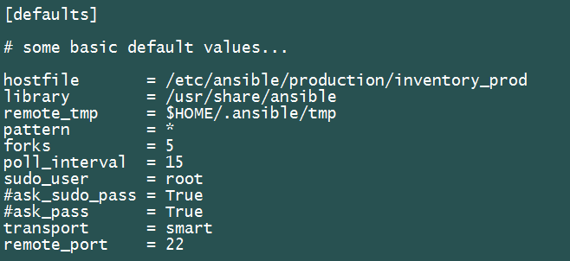

The ‘ansible.cgf’ file has ansible setting that one can modify to suit the environment.

This config file ‘ansible.cgf’ can be copied into the production folder and changes made in the file are then applied only for the playbooks located inside the folder.

**Ansible Modules**

* Core modules … modules supported by Ansible
* Extras … module updated created by community members and not supported by Ansible
* Deprecated … module that will be removed soon.

$ ansible-doc –l… to display all available core modules on ansible repo.

$ ansible-doc<module name>… man page for a module

$ ansible-doc –s <name>… help with some snippets on who to use a module inside a play book.

Core modules are categorized into multiple groups, like package deployment, network config, virtual machine, etc.

Common module that we can discuss are, ‘copy’ module, ‘fetch’, ‘apt’, ‘yum’, ‘service’ module etc.

Let’s use the module to install webserver on a centos machine.

We will use the yum module and provide input parameters for the module to work. Using below command over command line,

$ ansible<hostname>–i hosts –m yum –a “name=httpd state=present” –-become

$ ansible<hostname> -i hosts –m service –a “name=httpd enabled=yes state=started” --become

On the AWS DB node try running the yum module for package installation.

$ ansible<hostname> -i hosts –m apt –a “name=mariadb-server state=latest” --become

$ ansible<hostname> -i hosts –m service –a “name=mariadb state=started” --become

**Understanding the setup module**

‘Setup’ module is a module to gather facts from a system.

$ ansible web –i hosts –m setup –a “filter=ansible_os_family”

**Module usage with example:**

**File Module:**

$ ansible web –i inventory –m file –a “name=<path/filename> state touch”

$ ansible web –i inventory –m file –a “path=<path/filename> state touch”

**Copy Module:**

$ ansible web –i inventory –m copy –a “content<html><h1>Hello world</h1></html>dest=/var/www/html/index.html”

**Template Module**

$ ansible web –i inventory –m template –a “src=<path/file.j2>dest=<filepath>”

**User module**

$ ansible web - i inventory –m user –a “name=ganeshhp comment=Ganesh Palnitkar gid=4234 uid=4010”

**Package Modules**

$ ansible web – i inventory –m yum –a “name=ntp state=latest”

$ ansible web – i inventory –m apt –a “name=apache2 state=latest”

**Service module**

$ ansible web –I inventory –m service –a “name=apache2 state=started enabled=yes”

**Host /group Target pattern**

group1:group2 … grp1 OR grp2  
!group1 …. Not grp1

web*.autofact.com ….. wildcard

group1:&group2 … host machines that are only common with both groups only be applied with the change.

**Collecting Facts on remote system**

$ ansible<hostname> -i inventory –m setup –a “filter=ansible_eth*” …. This will run the ohai profiler on the remote server and gather facts and return those to the ansible server.

The command and shell modules are the only modules that just take a list of arguments and don’t use the key=value form. This makes them work as simply as you would expect:

tasks**:**

**-**name**:**enable selinux

command**:**/sbin/setenforce 1

The command and shell module care about return codes, so if you have a command whose successful exit code is not zero, you may wish to do this:

tasks**:**

**-**name**:**run this command and ignore the result

shell**:**/usr/bin/somecommand || /bin/true

Or this:

tasks**:**

**-**name**:**run this command and ignore the result

shell**:**/usr/bin/somecommand

ignore_errors**:**True

If the action line is getting too long for comfort you can break it on a space and indent any continuation lines:

tasks**:**

**-**name**:**Copy ansible inventory file to client

copy**:**src=/etc/ansible/hosts dest=/etc/ansible/hosts

owner=root group=root mode=0644

Variables can be used in action lines. Suppose you defined a variable called vhost in the vars section, you could do this:

tasks**:**

**-**name**:**create a virtual host file for{{**vhost**}}

template**:**

src**:**somefile.j2

dest**:**/etc/httpd/conf.d/{{**vhost**}}

**Play and Playbooks**

* Plays help to map the hosts to tasks.
* A play can have multiple tasks
* A playbook can have multiple plays.

A sample playbook, each coloured rectangle represents a play. Each play is mapped to the host or a group, parent group etc.

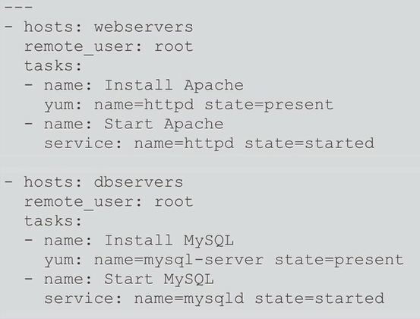

Play

Play

Using white space / indentation is very specific and has to be followed while writing the play / playbook.

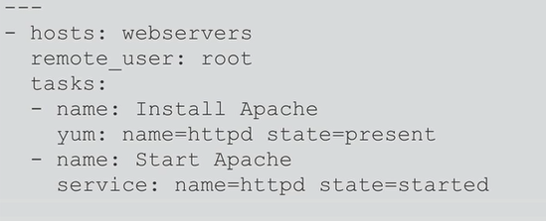

Tasks are executed in the order – top down. Thus we have to be careful while specifying the tasks in the play.

Tasks use modules

You can also control the order in which hosts are run. The default is to follow the order supplied by the inventory:

**-**hosts**:**all

order**:**sorted

gather_facts**:**False

tasks**:**

**-**debug**:**

var**:**inventory_hostname

Possible values for order are:

**inventory:**

The default. The order is ‘as provided’ by the inventory

**reverse_inventory:**

As the name implies, this reverses the order ‘as provided’ by the inventory

**sorted:**

Hosts are alphabetically sorted by name

**reverse_sorted:**

Hosts are sorted by name in reverse alphabetical order

**shuffle:**

Hosts are randomly ordered each run

To execute a playbook use the command,

$ ansible-playbook<playbook.yml>

Optional parameters to pass while executing playbook,

$ ansible-playbookplaybook.yml --step

$ ansible-playbookplaybook.yml --limit playbook.retry

A sample playbook, note the indentation and syntax used for writing tasks and modules.

* hosts: webserver

remote_user: root

sudo: yes

tasks:

- name: ensure apache is at the latest version

yum: name=httpd state=present

- name: start the apache service

service: name=httpd state=started enabled=yes

* hosts: dbserver

remote_user: root

sudo: yes

tasks:

-name: ensure MySQL is installed

apt: name=mariadb-server state=present

- name: ensure that MySQL service is started

service: name=mariadb state=started

We can verify the Playbook syntax using the Lint utility.

$ ansible-lint verify-apache.yml …here verify-apache.yml is a playbook.

One can also call a playbook inside a play., like shown below.,

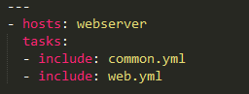

Notify Function can be used in the Playbook that calls the Handler. Handlers are list of Tasks listed under the tag of handlers that are invoked only on a certain condition in the execution of tasks.

handlers**:**

**-**name**:**restart memcached

service**:**

name**:**memcached

state**:**restarted

**-**name**:**restart apache

service**:**

name**:**apache

state**:**restarted

For failed task in the playbook execution one can use below command so as Ansible will confirm on running a particular task before executing it.

$ ansible-playbookplaybook.yml --step.The step asks you on before executing each task and you could choose (N)o/(y)es/(c)ontinue.

**Roles:**

In order to create roles, create a Directory named as Role inside the Ansible directory.

As shown below create directories and files inside the roles directory. Here ‘webserver’ is the role.

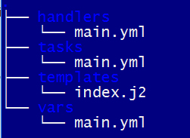

The tasks will be located in the tasks directory and written in main.yml file.

Roles hold the tasks inside the tasks folder in the main.yml file. So the main.yml file inside the tasks folder would appear as shown below.,

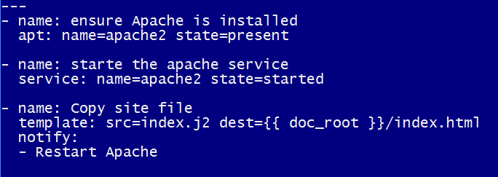

The file will only contain tasks and no hosts statement or vars definitions, etc.

The ‘vars’ folder thus has the main.yml file to store all variables for the role.

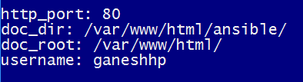

Similar to this the template folder would contain the template file, like index.j2, etc. and main.yml file inside ‘handler’ folder will have action statement as notified in ‘notify’ command.

In order to call the role inside a playbook we can use below syntax. The playbook in such case will be located outside the ‘roles’ folder. And will typically have syntax similar to one mentioned below.

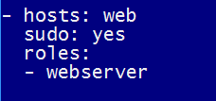

Here in this file we are calling the role with the ‘roles’ statement and then mentioned the role name.

**Ansible Galaxy for preconfigured roles.**

<https://galaxy.ansible.com>

Ansible provides a repository of ready-to-use roles for almost all requirements that you can think of.

Just pull the role to your Ansible controller and start using.

On the Galaxy web link we can explore all different roles categorized as, ‘Most starred’, ‘Most watched’, ‘Most Downloaded’, etc.

To install a particular role on to the Ansible control server, we can use the command,

$ ansible-galaxy install <role name>

Playbook- defining hosts and parameters

---

- hosts: servers

user: root

serial: 1 ***…..*** *how many remote servers can be targeted at a time. If there are hundreds of servers, we can set this number to 5 or 10.*

Some ansible ad-hoc commands:

$ ansible<hostname> -m shell –a <shell command> --sudo….. Here we can pass a shell command to be executed on a remote machine.

How to secure file or a string.

Ansible Vault

$ ansible-vault [create|decrypt|edit|encrypt|encrypt_string|rekey|view] [options] [vaultfile.yml]

Common Options

--ask-vault-pass

ask for vault password

--new-vault-id <NEW_VAULT_ID>

the new vault identity to use for rekey

--new-vault-password-file

new vault password file for rekey

--vault-id

the vault identity to use

--vault-password-file

vault password file

--version

show program’s version number and exit

-h, --help

show this help message and exit

-v, --verbose

verbose mode (-vvv for more, -vvvv to enable connection debugging)

To create a new encrypted key file

$ ansible-vault create abc.yml(a file abc.yml is create which will have encrypted contents stored)

To encrypt existing file

$ ansible-vault encrypt existing.yml

To update or rekey files

$ ansible-vault rekey abc.yml

Editing an encrypted file

$ ansible-vault edit abc.yml

Viewing an encrypted file

$ ansible-vault view abc.yml

Decrypting files

$ ansible-vault decrypt abc.yml

To use an encrypted file while executing a playbook.

$ ansible-playbook –i hosts abc.yml --ask-vault-pass

This will prompt the user for supplying vault password.

Few handy commands on Ansible...

$ ansible-doc –t <type_of_module_from_list> --list

Types of docs we can list...

{become,cache,callback,cliconf,connection,httpapi,inventory,lookup,netconf,shell,module,strategy,vars}]

Below commands can help to list all default config values that are defined in the Ansible.cfg file.

$ ansible-config –version {list dump view}

Using inventory command to list all devices from inventory file.

$ ansible-inventory --list

**Using Ansible for Windows management.**

Pre-Requisites before we get started for managing Windows hosts using Ansible.

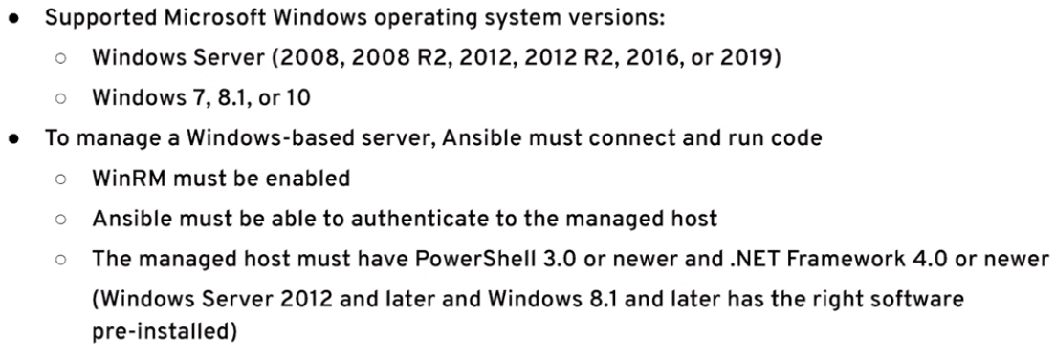

On the Ansible Control server install the python package, pywinrm using below command.

$ sudo yum install python-pip

$ sudo pip install pywinrm

Update the inventory file on the Ansible control server by adding the windows machine entry.

[windows] 172.31.42.206

[windows:vars] ansible_connection=winrm ansible_user=<username> ansible_password=<password>

ansible_winrm_server_cert_validation=ignore ansible_winrm_transport=basic ansible_winrm_port=5985

Now, on the windows machine that we want to manage using Ansible, make few changes as show below.

ps> winrm quickconfig–q

ps> winrm set winrm/config/service ‘@{AllowUnencrypted=”true”}’

ps> winrm set winrm/config/service/path ‘@{Basic=”true”}’